Requierment update #3

New requirement:

1. Add multiple language support
   1. The application should have a lookup file, to configure English and Chinese display, including display_name, English_display, Chinese display.

example: “Welcome”, “Welcome”, “欢迎”

* 1. When user creates profile, add one option “preferred language” in the profile.
  2. on the main page, add a language option toggle to switch between English and Chinese:
     1. when user not logged in, use the language option the user can switch the language
     2. after the user login, the language should switch based on preferred language setting, language option toggle should update the display based on the current language
     3. the user still have the option to choose a session language display using the language toggle (overwrite the preferred language setting)

1. if user login as teacher or student, add a “My Classes” on the manu, the following “Your Classes” should be displayed under the “My Classes” as well

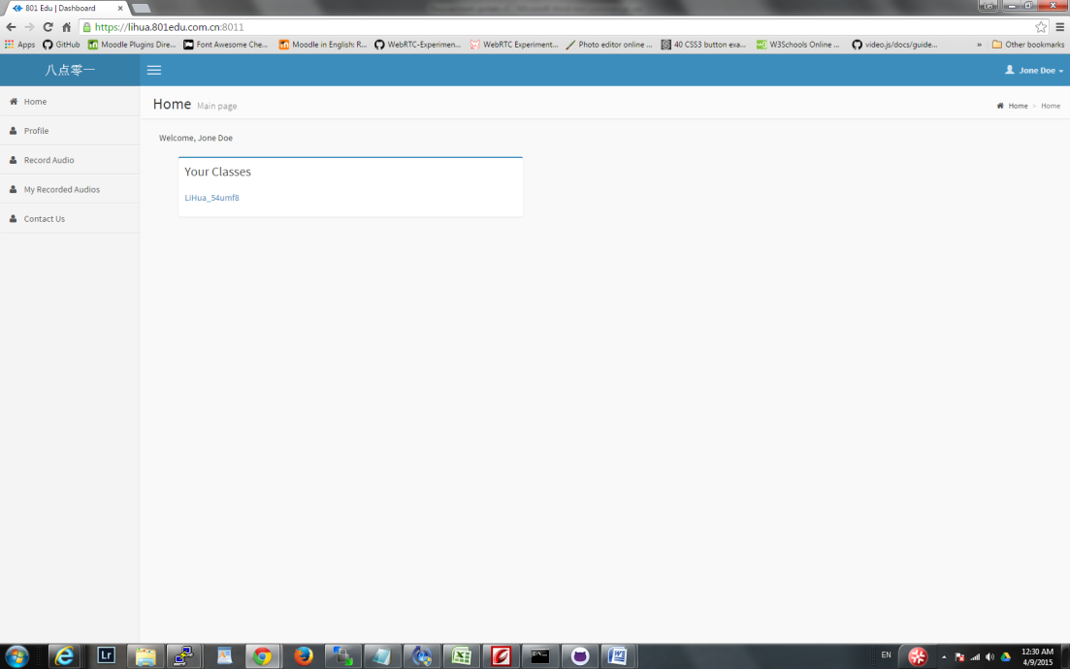

1. On “Class”,
   1. Add a new field “class name”
   2. add the ability for teacher and admin to upload class materials, multiple documents/pictures etc can be uploaded.
2. Add a new function: Class Session
   1. Session belong to a class
   2. Each class will have multiple sessions (currently up to 60, but no upper limit)
   3. Admin can add new sessions to the class after the class information is saved
   4. Each session will have the following attributes:
      1. session ID (system generated value) ,
      2. session date,
      3. start time,
      4. duration
      5. comments
      6. notification
   5. Session Start time the default value of the class start, but is editable
   6. Session Duration should be the default value of class duration, but is editable
   7. Session is displayed as a table and can be edited in the table.

|  |  |  |  |  |
| --- | --- | --- | --- | --- |
| Session ID | Session Date | Start Time | Duration (minutes) | Comments |
| 1 | March 6, 2015 | 16:00 | 60 |  |
| 2 | March 13, 2015 | 16:00 | 60 |  |
| 3 |  |  |  |  |
| 4 |  |  |  |  |
| … |  |  |  |  |

1. Once a user select a course/class, add the following information on the display:
   1. List of class sessions, including session date, start time, duration, notification
2. Add login screening:
   1. When user registered, display a random picture with imbedded number/character for the user to type – to avoid machine registration
   2. After user create the profile, the account will remain inactive, send verification email to registered email address for verification and activate the account.
   3. Admin user can manually activate an account.
3. Change teacher/student type identification:
   1. When user registered, the type “teacher” or “student” in the profile is invisible to the user, all registered user will be default to type “student”
   2. Admin user will be able to manually set a user to be “teacher”
      1. Admin user will have the privilege to view/modify user profile
      2. Admin user can search user by userid or email address.

Modification of current functions:

1. Add the following information to users:
   1. Userid - de-couple userid with email address, the use should be able to specify an unique username
   2. Screenname - this name will be the name displayed on the screen, default to the first name
   3. Wechat ID
   4. QQ ID
   5. Zip code
   6. Comments
2. Change the drop down list display:
   1. When display classes, under the following screens, in class drop down, don’t display the class ID, which is not readable. Instead use the new field Class Name

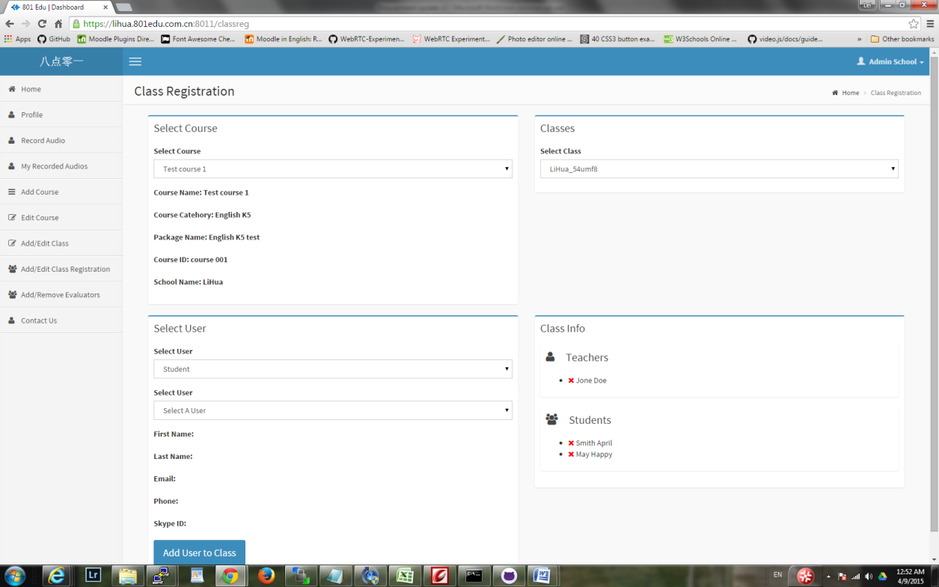

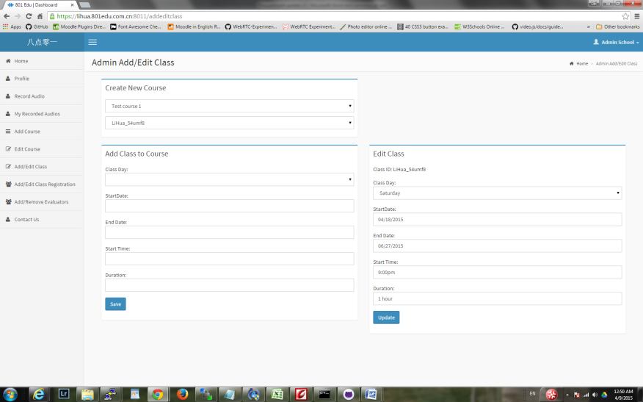

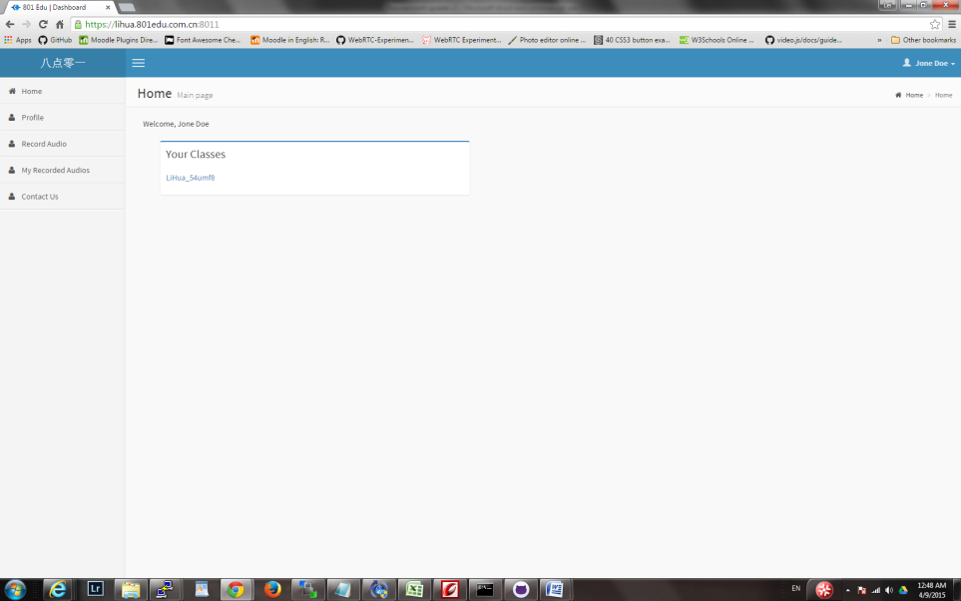

1. When add user to class registration, the user drop down list currently just displayed first name, we need to display the full name plus the username for identification, for example, username happymay, first name May, last name Happy, the drop down list should show

Happymay Happy May

This is to avoid duplicate names that will cause issue.

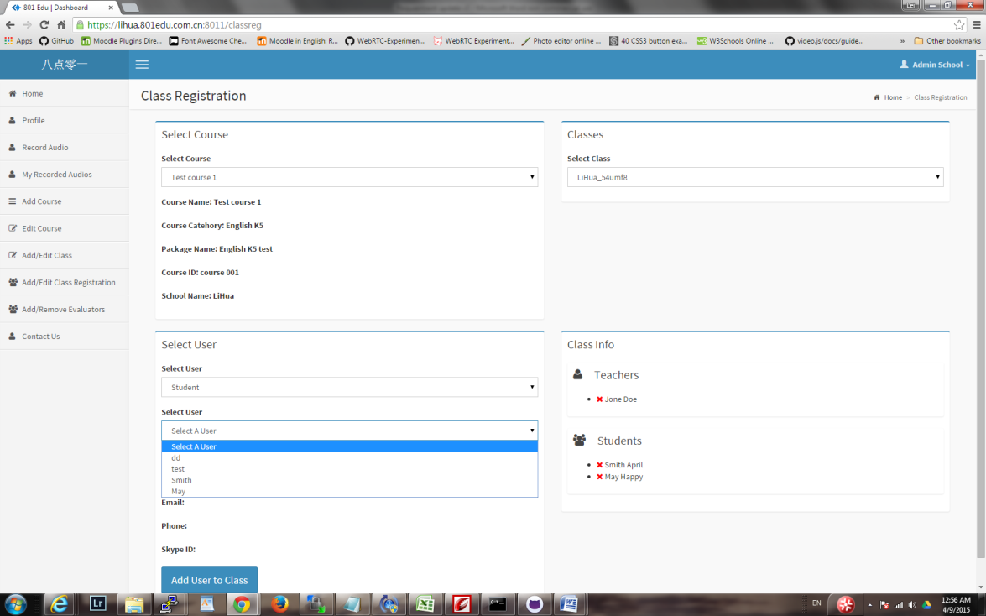

1. ,